# TO SUPPLY LEFTOVER FOOD TO POOR

**TEAM MEMBERS:**

SANDHIYA A - Team Leader - (AU710621104041) RISHWANTH S - (AU710621104036)

SIRAN KUMAR C - (AU710621104311) ASHWIN N - (AU710621104004)

**NM_ID**: 67FAB993AC7983F9C4E42D6BF7FF7C76

**Github Link**: https://github.com/Sandhiyah/To-Supply-Leftover-Food-to-Poor.git

**TrailheadURL**: https://www.salesforce.com/trailblazer/closz78bvzpz2jwk61

**Demo Link**:

https://drive.google.com/file/d/189GAaR8WDlv42vNsA3dwX0JOKQakQBm_/view?usp=drive_link

# TO SUPPLY LEFTOVER FOOD TO POOR

## PROJECT OVERVIEW

This document provides a comprehensive overview of the “To supply leftover food to the poor”. The primary objective of this project is to create a platform leveraging Salesforce technology to efficiently connect surplus food from various sources with organizations or individuals in need. This initiative aims to minimize food wastage and alleviate hunger by facilitating the redistribution of excess food to those who are food insecure.

**Milestone 1: Salesforce Developer Account Creation**

The project begins with the creation of a Salesforce developer account, which is essential for accessing Salesforce's features. Users fill out a registration form with their details and verify their account via email. This step lays the groundwork for all subsequent development activities within the Salesforce environment.

**Milestone 2: Object Creation**

In this phase, various custom objects are created to manage the food donation process effectively. Key objects include Venue, Drop-Off Point, Task, Volunteer, and Execution Details. Each object is defined with specific attributes that facilitate organized data management and reporting capabilities, ensuring that all relevant information is captured systematically.

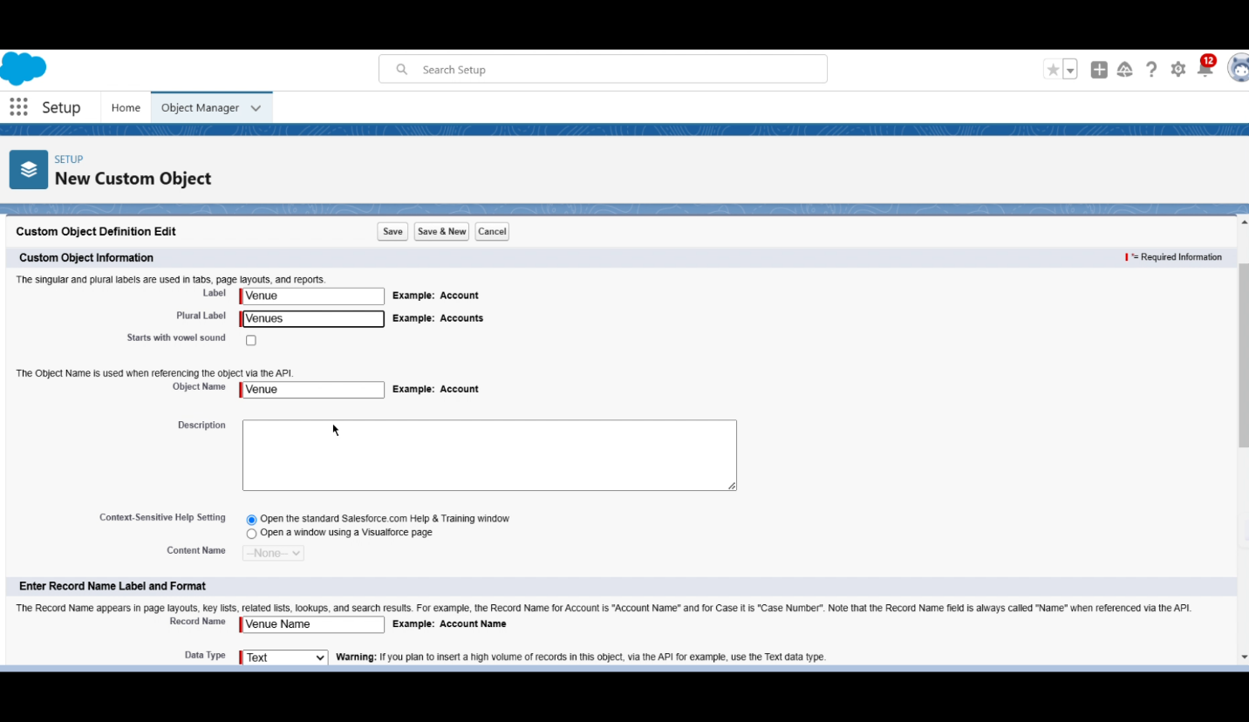

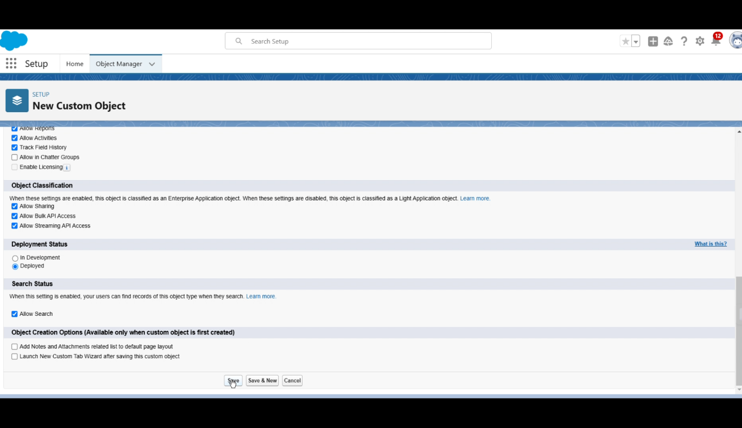

**Milestone 3: Tabs Creation**

This milestone involves creating custom tabs for the previously defined objects. These tabs serve as user interfaces that allow users to easily navigate and manage records related to venues, drop-off points, tasks, volunteers, and execution details. This enhances user accessibility and interaction with the system.

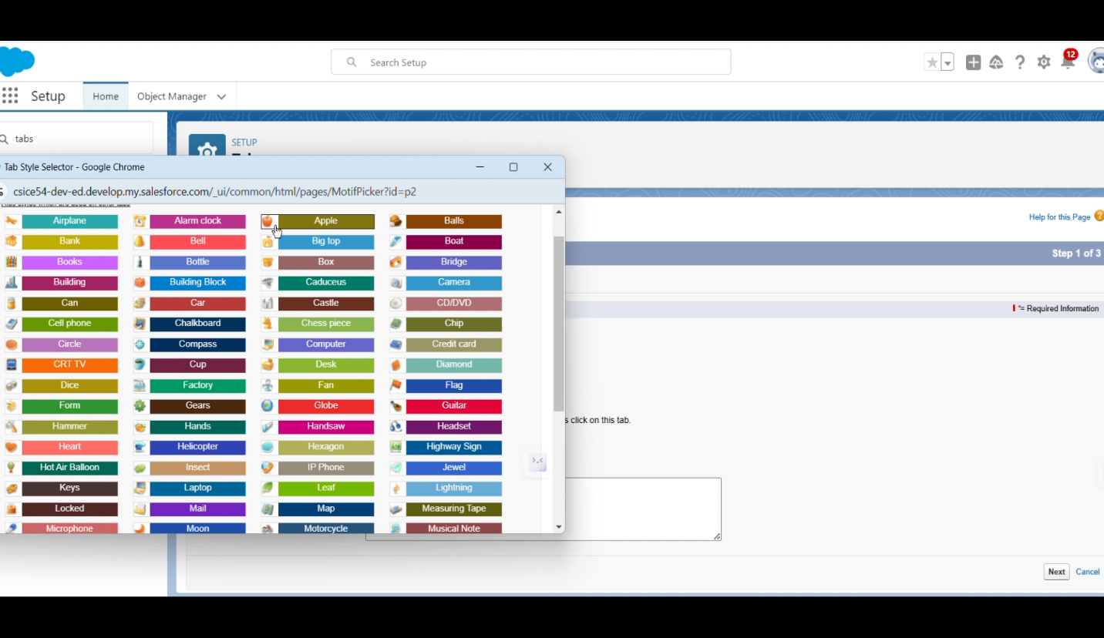

**Milestone 4: The Lightning App**

A Lightning App named "FoodConnect" is developed in this stage to provide a cohesive user experience. The app integrates various navigation items related to the project, allowing users to access different functionalities seamlessly. This step significantly improves the usability of the platform.

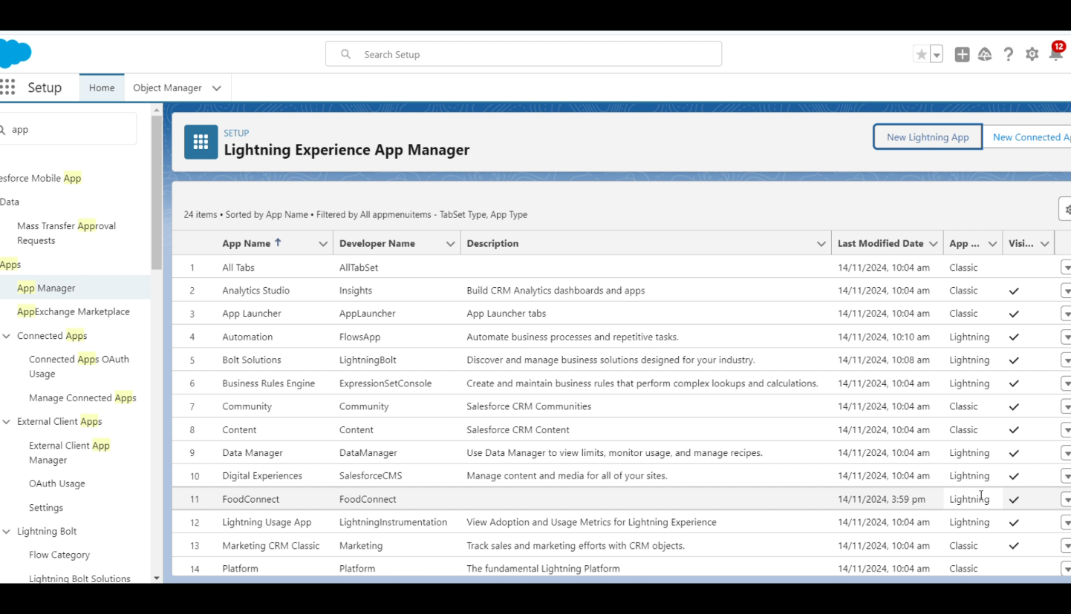

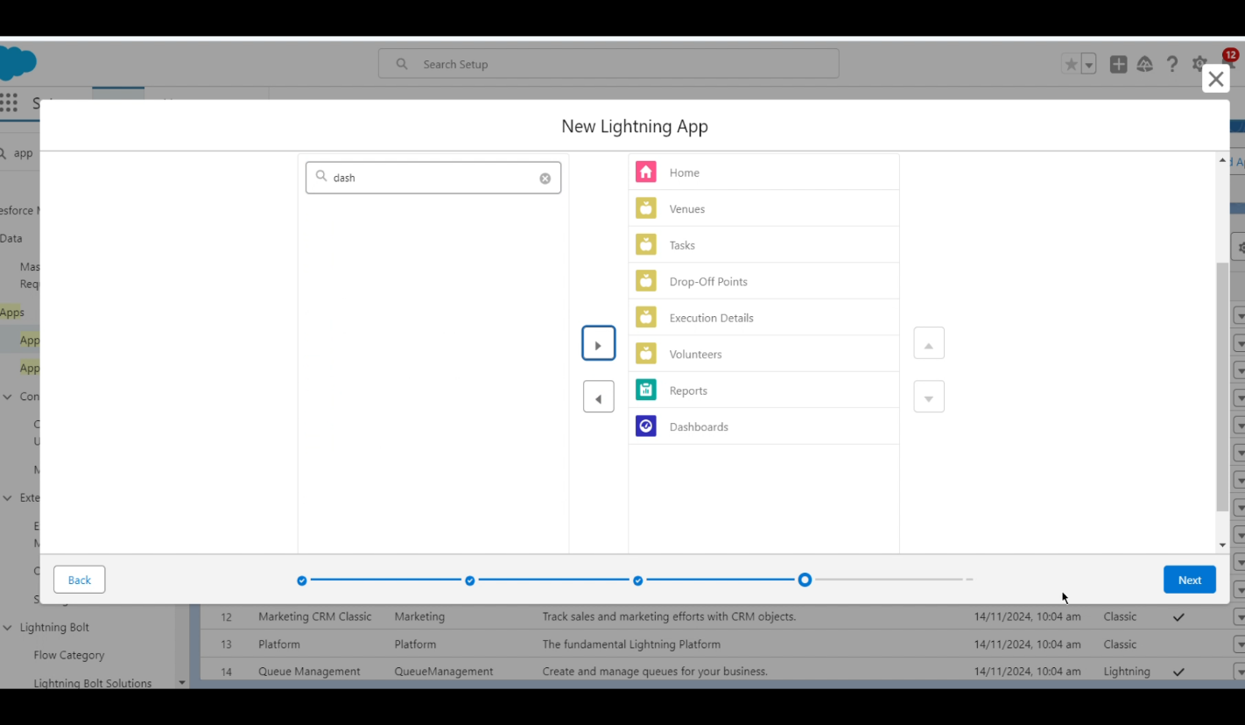

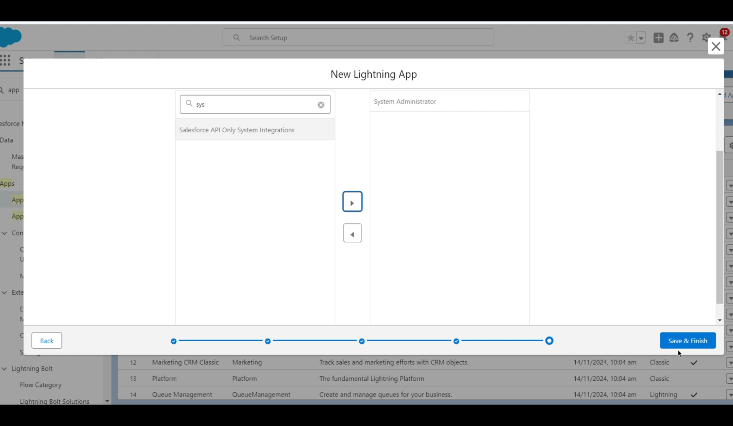

**Milestone 5: Field Creation**

Fields are established within the custom objects to capture essential information such as contact details, location data, and task attributes. This includes creating relationship fields that link different objects together, which is crucial for maintaining data integrity and facilitating complex queries within the system.

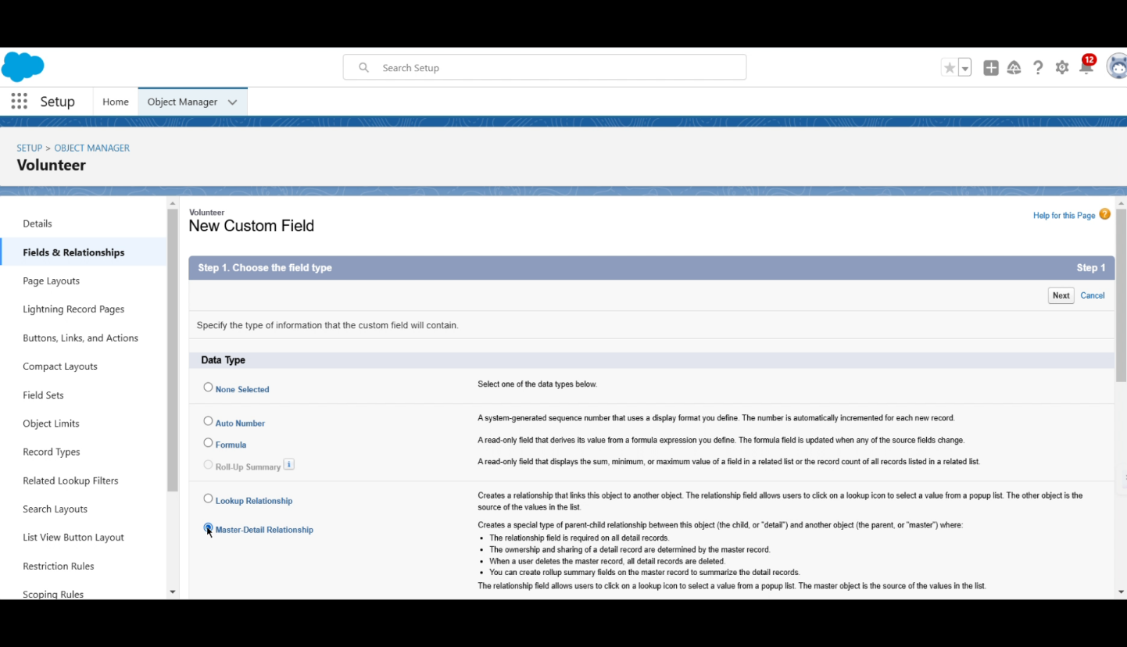

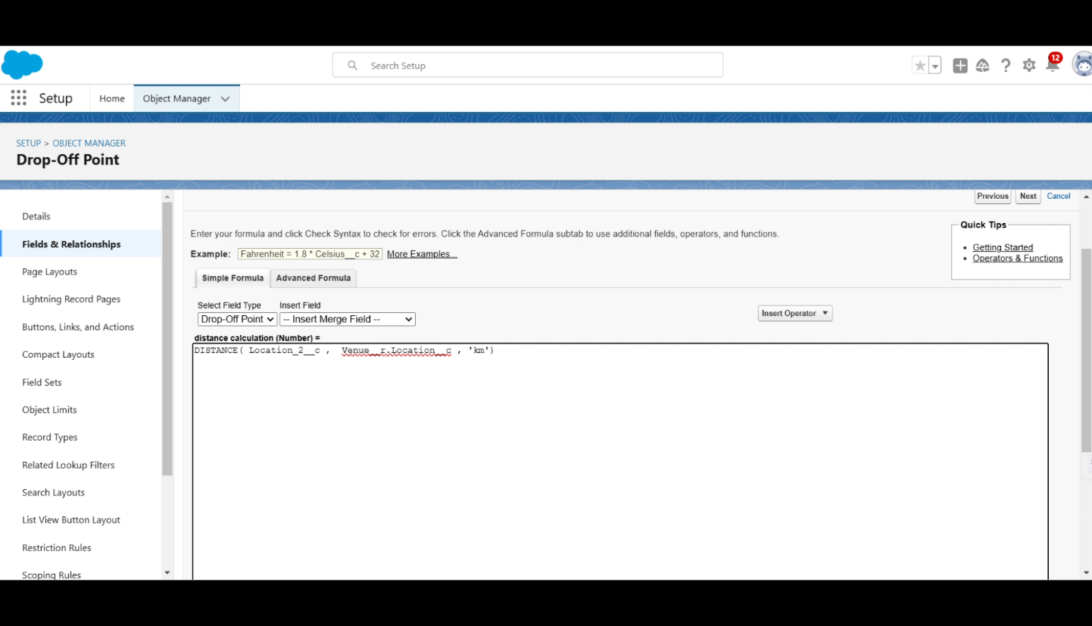

**Milestone 6: Flows Development**

Salesforce Flows are designed to automate various processes within the application. This step simplifies workflows by guiding users through complex tasks without requiring extensive coding knowledge. Flows enhance efficiency and ensure that processes are executed consistently.

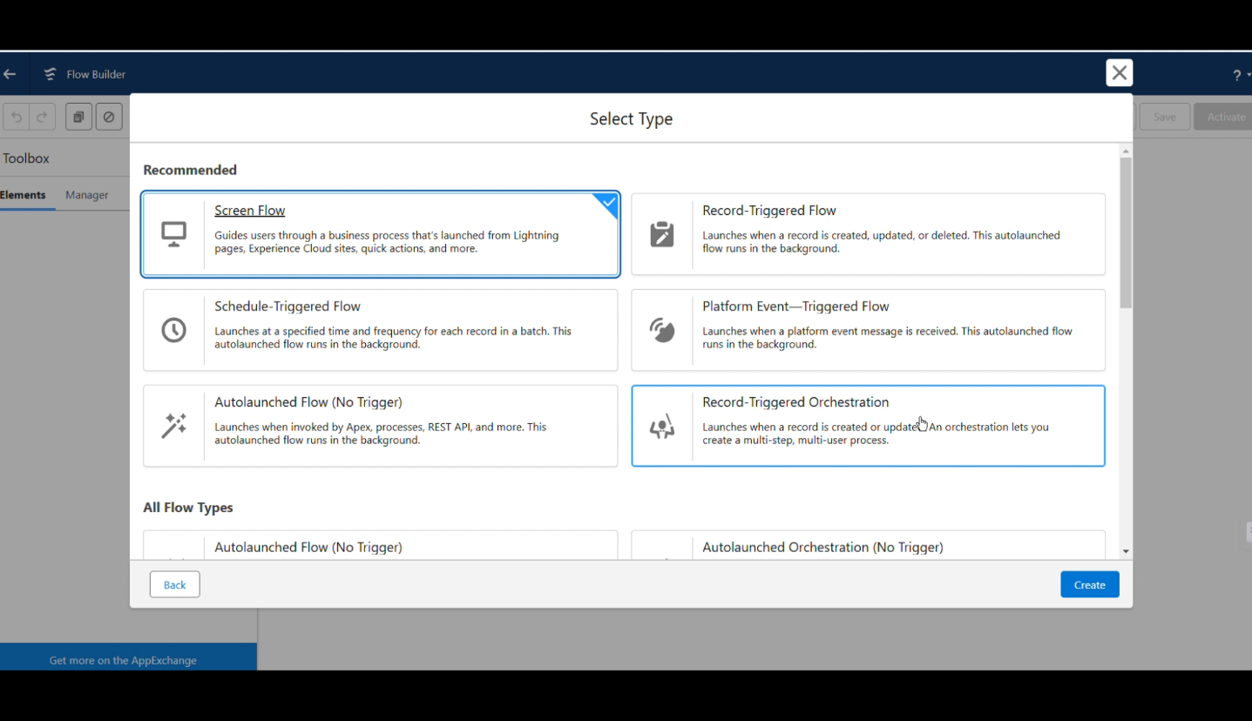

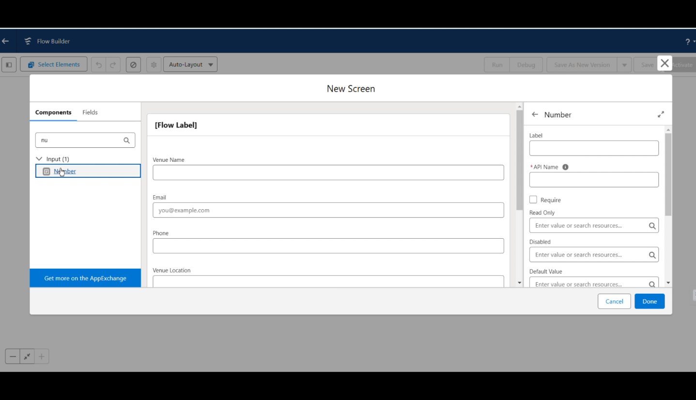

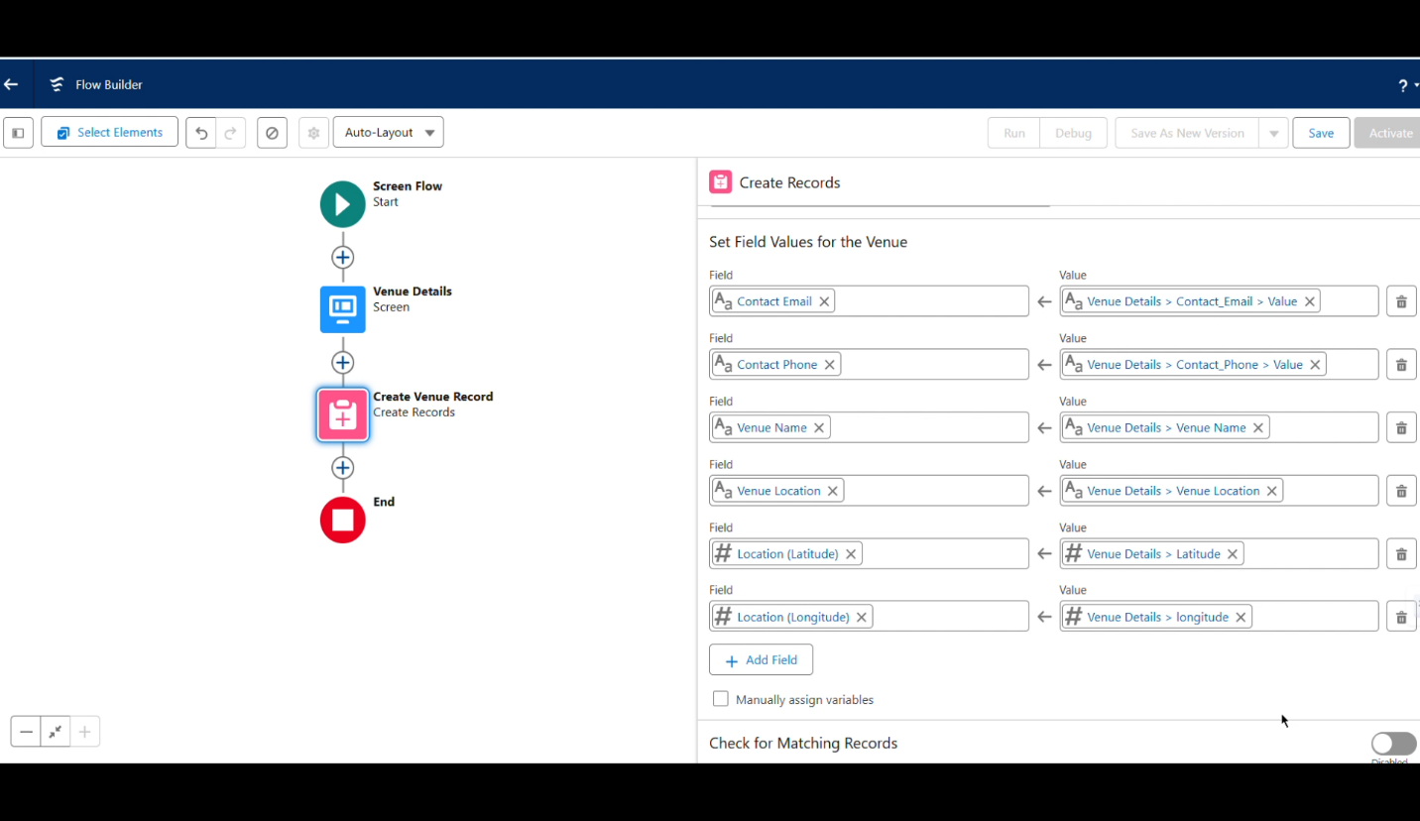

**Milestone 7: Trigger Implementation**

Triggers are set up to automatically execute specific actions based on predefined conditions within Salesforce. This automation ensures that critical tasks related to food donation management are performed efficiently and without manual intervention, thereby streamlining operations.

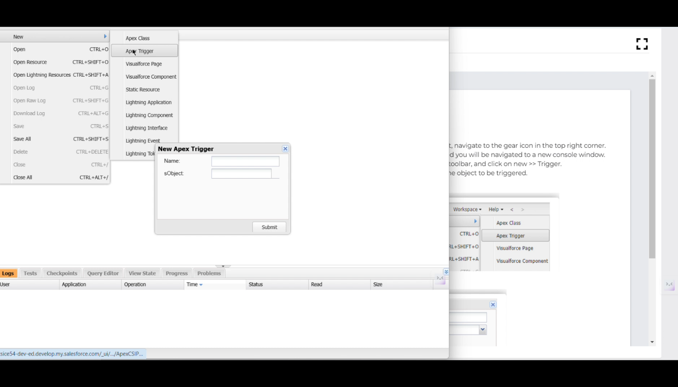

**Milestone 8: Profiles Configuration**

User profiles are configured to manage access permissions within the application. This step ensures that users have appropriate access levels based on their roles in the food donation process, enhancing security and operational efficiency.

**Milestone 9: User Creation**

New users are created in the system to allow volunteers and staff members access to the application. Each user is assigned a profile that determines their permissions and capabilities, ensuring that everyone can perform their designated tasks effectively.

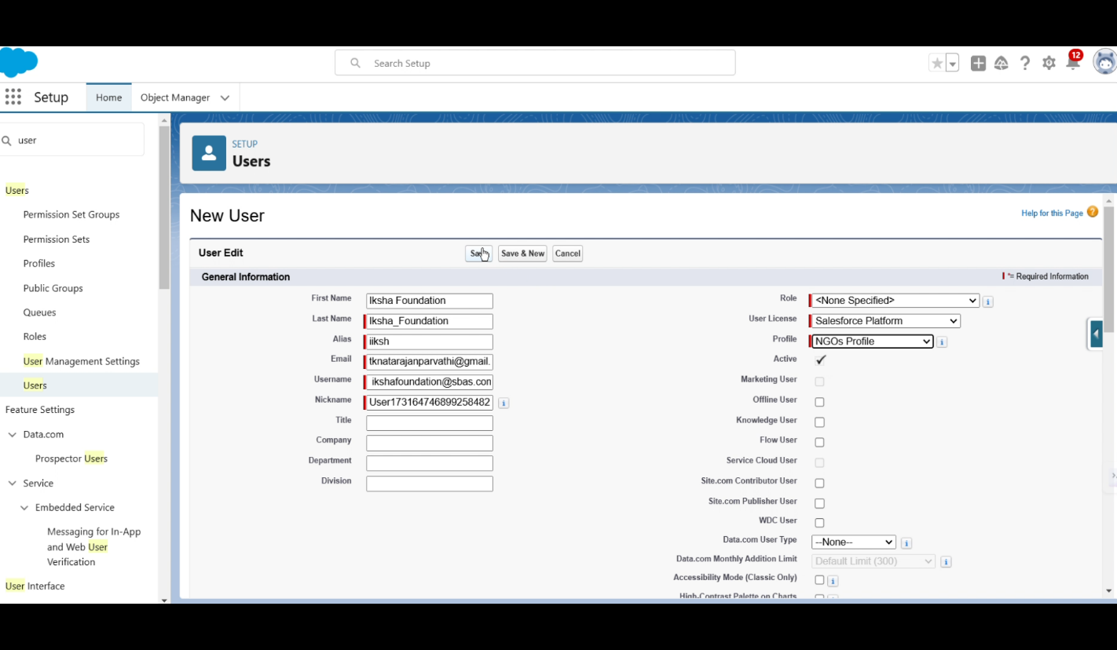

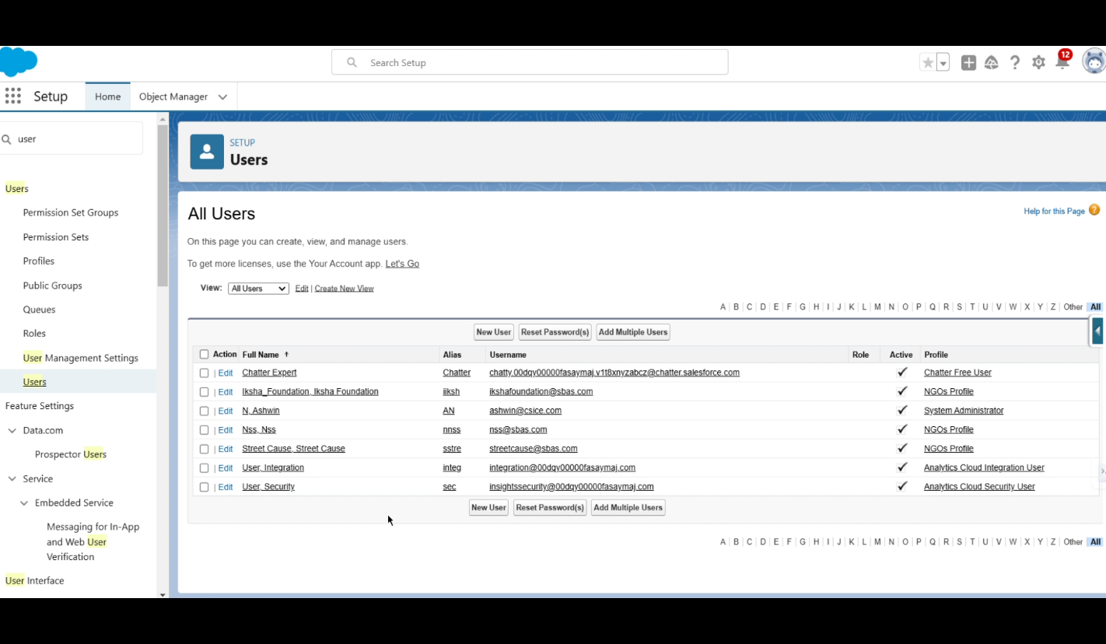

**Milestone 10: Public Groups Setup**

Public groups are established to facilitate collaboration among users with similar roles or responsibilities. This grouping enhances communication and task management, allowing team members to work together more effectively in achieving project goals.

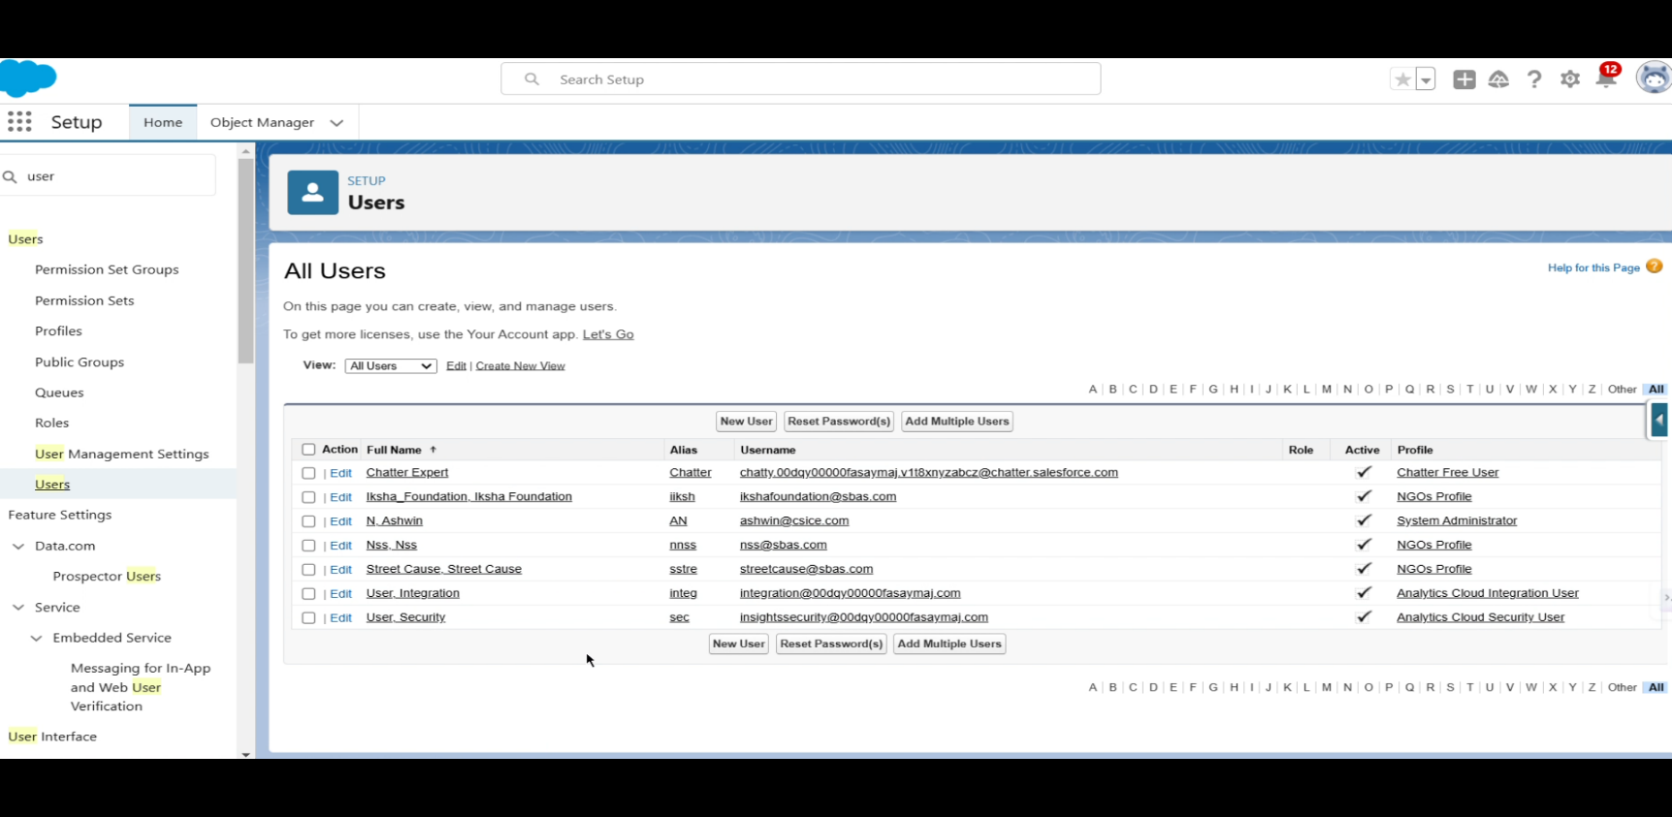

**Milestone 11: Report Types Definition**

Various report types are defined to analyze data related to food donations. This step allows stakeholders to track progress and assess the effectiveness of the initiative through customized reporting capabilities tailored to specific needs.

**Milestone 12: Report Generation**

Reports are generated based on the defined report types, providing insights into key metrics such as food collected, distributed, and volunteer engagement. These reports assist in evaluating the project's impact and inform decision-making processes.

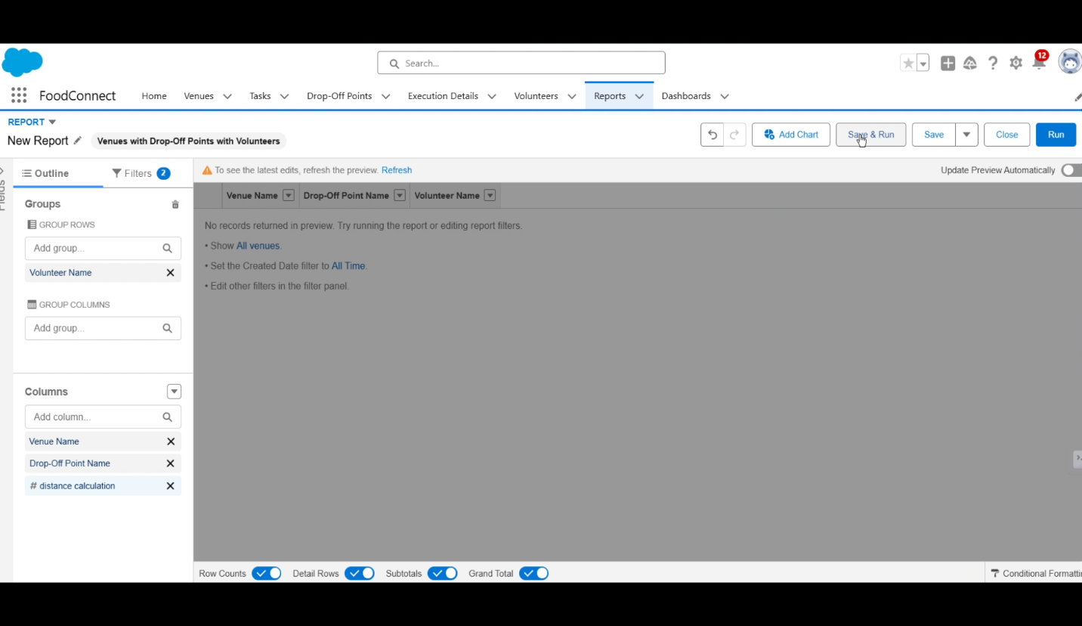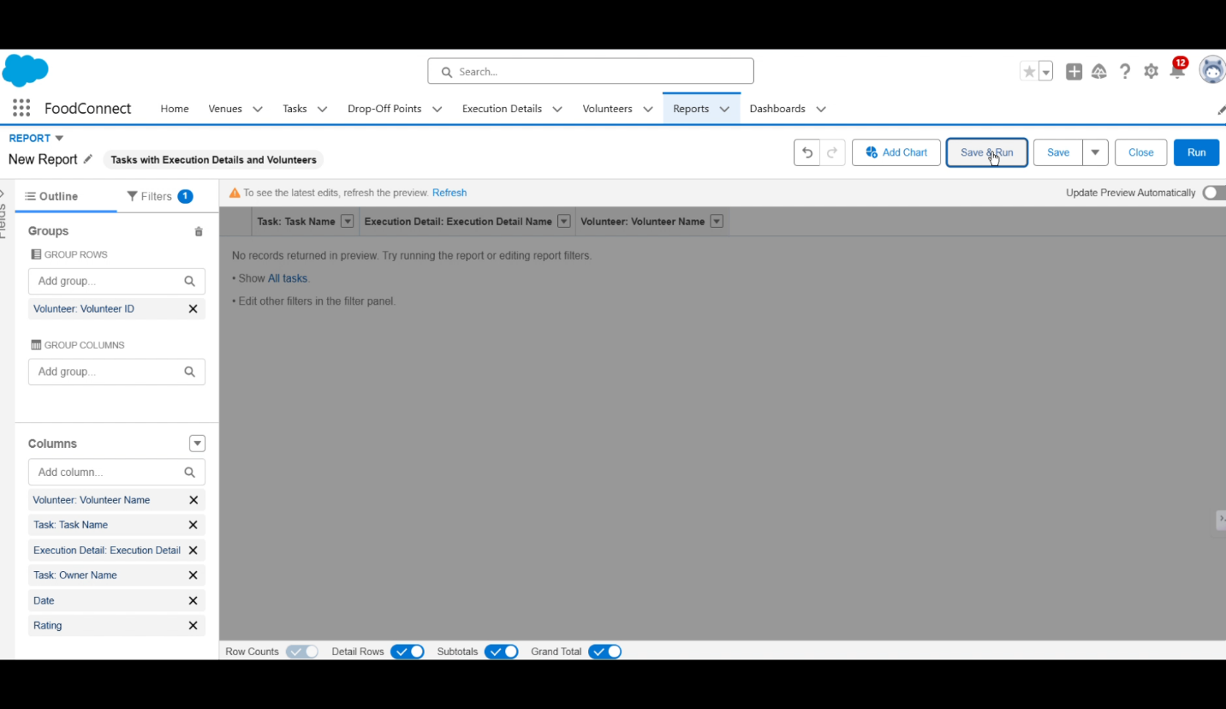

**Milestone 13: Dashboard Creation**

Dashboards are developed to visually represent data from reports. This provides stakeholders with an at-a-glance view of important metrics related to food redistribution efforts, enhancing overall visibility into project performance.

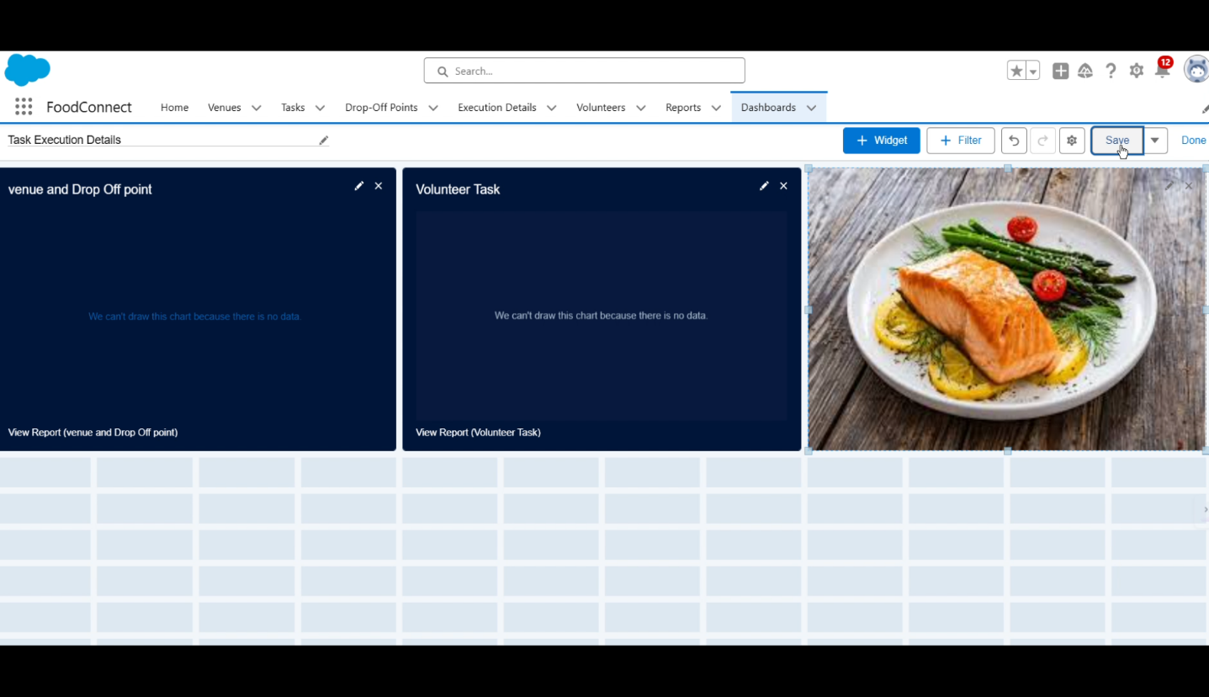

**Milestone 14: Sharing Rules Establishment**

Sharing rules are set up to control data visibility among users, ensuring sensitive information is only accessible to authorized personnel while promoting collaboration among team members.

**Milestone 15: Home Page Customization**

The home page of the application is customized to improve user experience by displaying relevant information and quick links to essential functions within the app. This personalization helps users navigate more efficiently.

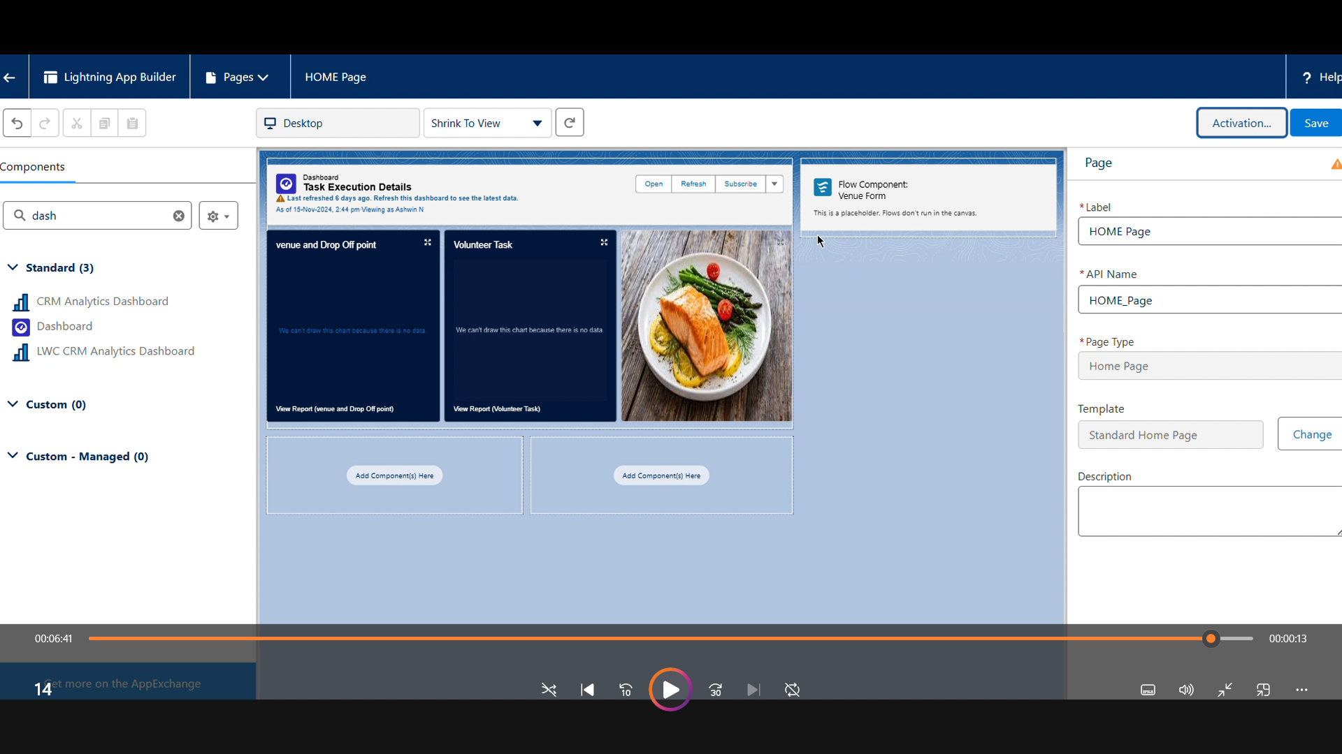

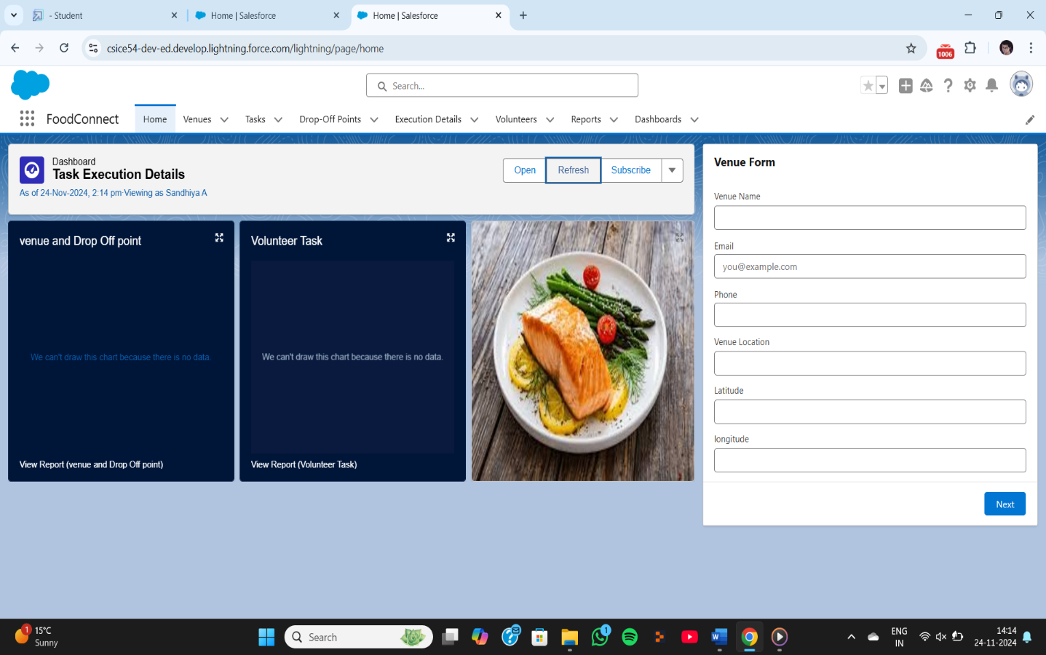

**Milestone 16: Conclusion**

The final milestone summarizes the project's achievements and outlines future steps for sustainability and scalability. It emphasizes ongoing efforts to minimize food wastage and support those in need through effective use of technology, ensuring that the initiative remains impactful over time. By leveraging the Salesforce platform, the project successfully established a streamlined and transparent system for managing surplus food donations. Through efficient coordination with volunteers and timely delivery to beneficiaries, the project effectively addressed food insecurity while maximizing the utilization of available resources.